**STUDENT RESOURCE**

**A Mini-Project Report**

**Under**

**Project Workshop**

***Submitted by***

**KAUSTABH DUTTA B023**

**MIHIR GANDHI B025**

**TEJAS JADHAV B037**

**APARAJIT GUPTA B035**

***Under The Guidance Of***

POONAM GUPTA

***in partial fulfillment for the award of the degree***

***of***

**BACHELOR OF TECHNOLOGY**

**IN**

**COMPUTER ENGINEERING**

**at**

**MUKESH PATEL SCHOOL OF TECHNOLOGY MANAGEMENT AND ENGINEERING, NMIMS UNIVERSITY, VILE-PARLE**

**APRIL, 2015**

**CERTIFICATE**

This is to certify that the project entitled “**Student Resource”** is the bonafide work carried out by **Kaustabh Dutta, Mihir Gandhi, Aparajit Gupta and Tejas Jadhav,** B.Tech (Computer Engineering), MPSTME (NMIMS), Mumbai, during the fourth semester of the academic year 2014-2015, in fulfillment of the requirements for the award of the Degree of Bechelors of Technology as per the norms prescribed by NMIMS. The project work has been assessed and found to be satisfactory.

Internal Mentor

_______________________ ________________________

Examiner 1 Examiner 2

________________________

Dean

Dr. D.J. Shah

**DECLARATION**

We, **Kaustabh Dutta, Mihir Gandhi, Aparajit Gupta, Tejas Jadhav** of B.Tech (Computer Engineering), semester- IV, understand that plagiarism is defined as anyone or combination of the following:

1. Un-credited verbatim copying of individual sentences, paragraphs or illustration (such as graphs, diagrams, etc.) from any source, published or unpublished, including the internet.

2. Un-credited improper paraphrasing of pages paragraphs (changing a few words phrases, or rearranging the original sentence order)

3. Credited verbatim copying of a major portion of a paper (or thesis chapter) without clear delineation of who did wrote what.

4. We have made sure that all the ideas, expressions, graphs, diagrams, etc., that are not a result of our work, are properly credited. Long phrases or sentences that had to be used verbatim from published literature have been clearly identified using quotation marks.

5. We affirm that no portion of my work can be considered as plagiarism and we take full responsibility if such a complaint occurs. We understand fully well that the guide of the seminar/ seminar report may not be in a position to check for the possibility of such incidences of plagiarism in this body of work.

Signature of the Students:

Name: _____________ _____________ _____________ _____________

Roll No. _____________ _____________ _____________ _____________

Place: Mumbai

Date: April 2015

**ACKNOWLEDGEMENT**

We would like to thank our teacher, **Ms. Poonam Gupta,** for helping and guiding us throughout our venture into the world of Android. This being our first ever attempt at creating an application, we did come across hurdles and faced a lot of difficulties. She devoted an ample amount of her working time towards solving our queries and difficulties, for which we are really thankful.

**TABLE OF CONTENT**

|  |  |  |
| --- | --- | --- |
| **Sr. No.** | **Topic** | **Page No.** |
|  | List of figures | i |
|  | Abbreviations | ii |
|  | Abstract | iii |
| 1 | Introduction | 1 |
| 1.1 | Problem Specification | 1 |
| 1.2 | Solution Outline | 1 |
| 1.3 | Application/Usage | 1 |
| 2 | System Analysis | 2 |
| 2.1 | Existing System | 2 |
| 2.2 | Software Requirement | 2 |
| 2.3 | Hardware Requirement | 2 |
| 3 | Design and Methodology | 3 |
| 3.1 | Flowchart of app | 3 |
| 3.2 | Output | 3 |
| 3.3 | Limitation of app | 11 |
| 4 | Conclusion and Future Scope | 12 |
| 5 | References | 13 |

**LIST OF FIGURES**

|  |  |  |
| --- | --- | --- |
| **Sr. No.** | **Title** | **Page No.** |
| 1. | Flow Chart | 3 |
| 2. | Main Page | 4 |
| 3. | Computer Page | 5 |
| 4. | IT Page | 6 |
| 5. | Mechanical Page | 7 |
| 6. | Civil Page | 8 |
| 7. | Faculty Page | 9 |
| 8. | Year 1 Page | 10 |

i

**ABBREVIATIONS**

SDK – Software Development Kit

ADK – Accessory Development Kit

IDE – Integrated Development Environment

ii

**ABSTRACT**

Engineering in any field is not an easy task. Having a busy day to day schedule in their colleges and studying at home, students have to work really hard to achieve a B.Tech or a B.E degree.

We have developed an app that will make a student’s life a bit easier. We have developed an app called “Student Resource” that will provide the students of any engineering college a list of books to refer throughout their 4 years course. This app has a simple layout consisting of a home page which will show the user a few buttons (Computer, IT, Mechanical, Civil) that will direct the user to his/her stream. Then the user can view 5 buttons (Faculty, year 1, year 2, year 3, year 4). These buttons should help the user to choose the year he/she is currently in. Now behind these buttons the user can find his courses and the notes beneath the courses. In the faculty section, the user can see a list of the teachers for that year and stream.

iii

1. **INTRODUCTION**

**1.1 Problem specification**

* The app **Student Resource** will serve as a complete guide for the students who enter the college from their first year to the last day of their college life.
* We remember the first time we entered college and were very easily burdened with several books for each subject without having proper guidance on what to study for each subject and how to study for each test.
* We found new teachers and each teacher had a different approach towards teaching.
* Understanding what the teacher expected from us would have made our lives a lot easier.

**1.2 Solution Outline**

* The app contains different pages for all the 4 years of different streams of engineering and also the specific book names to refer to for each subject in each semester.
* It also contains a teacher review system where a student can rate a teacher, and explain their teaching methodology and skills so that the future students are benefitted from it.
* It would also provide links for each mentioned book so that students can download the notes directly.

**1.3 Applications**

* It provides a one stop solution to study for class tests and semester end exams for all engineering students.
* It is a college specific app so different colleges can implement the app in their own colleges.
* The students gain insight on the teachers’ teaching methods and can prepare in advance for all the difficulties they may have to face.

1

1. **SYSTEM ANALYSIS**
   1. **Existing System**

* Main Page
* Computer
* Mechanical
* Civil
* IT
* Faculty
* Year 1
* Year 2
* Year 3
* Year 4
  1. **Software Requirement**
* **Phone**
* OS – 4.0(Ice cream sandwich) and higher
* Resolution – HD preferable
* Java Support
* **Computer**
* OS – Any from among Linux/Microsoft/iOS
* Software – Android Studio 1.0.1 or higher OR Eclipse IDE with ADT plug-in and SDK tools
  1. **Hardware Requirement**
* **Phone**
* RAM – 1 GB or higher
* Processor – Quad Core or higher
* **Computer**
* RAM – 4 GB or higher

2

1. **DESIGN AND METHODOLOGY**
   1. **Flow Chart of App**
   2. **Output**
      1. **Main Page**

3

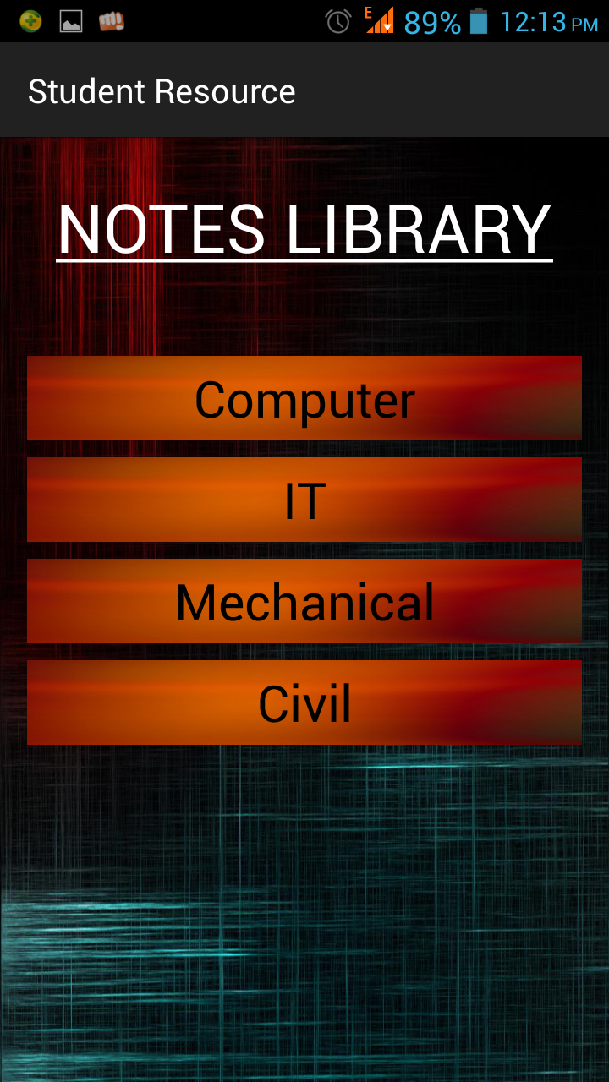

4

* + 1. **Computer Page**

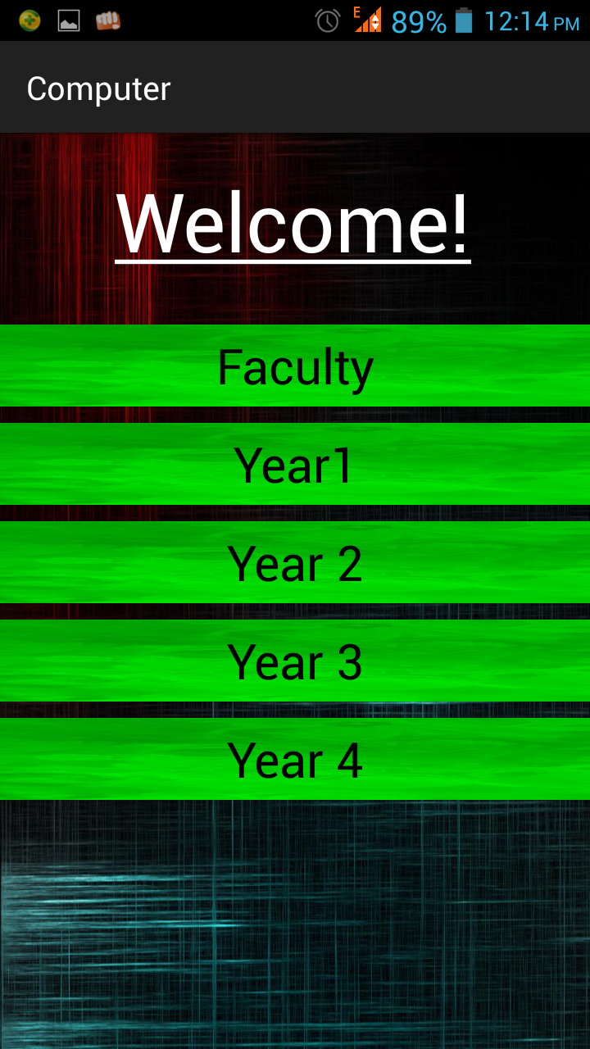

5

* + 1. **IT Page**

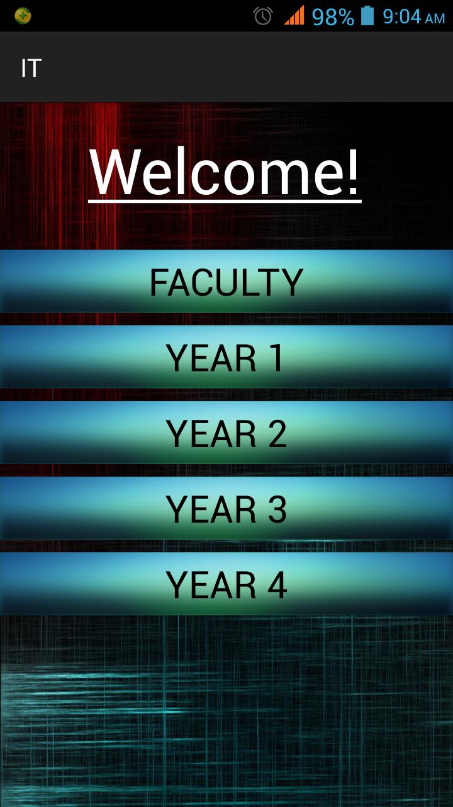

6

* + 1. **Mechanical Page**

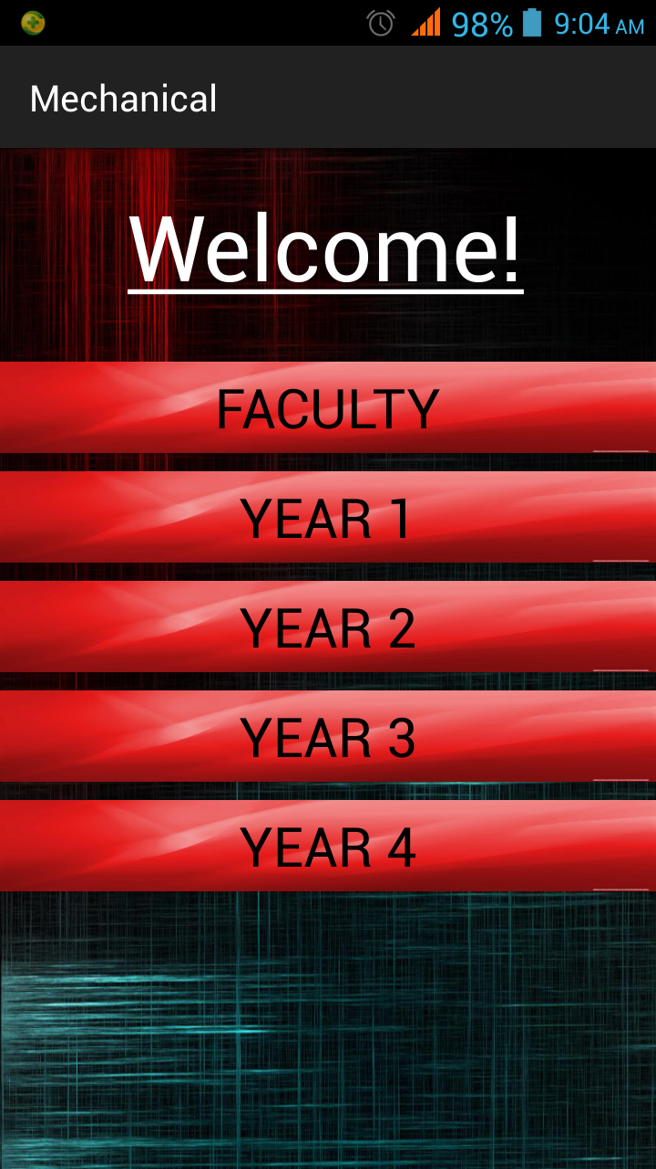

7

* + 1. **Civil Page**

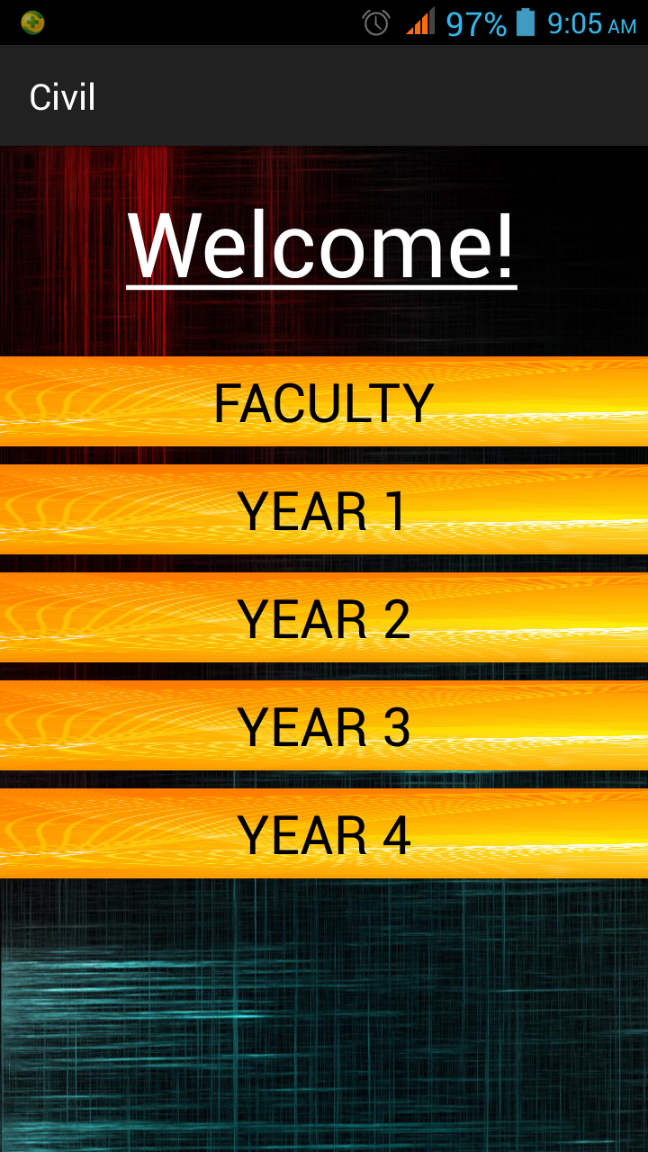

8

* + 1. **Faculty Page**

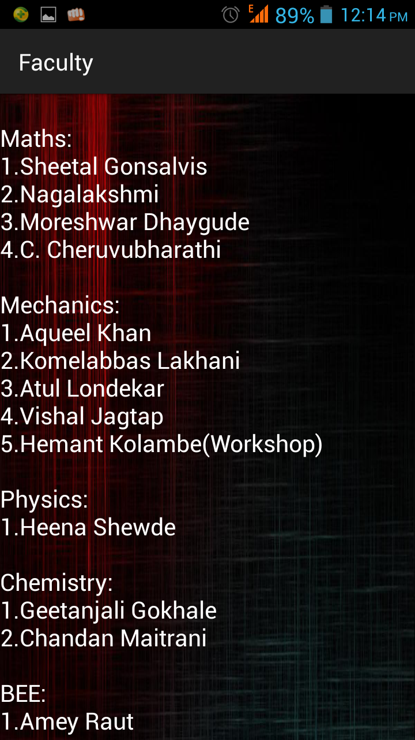

9

* + 1. **Year 1 Page**

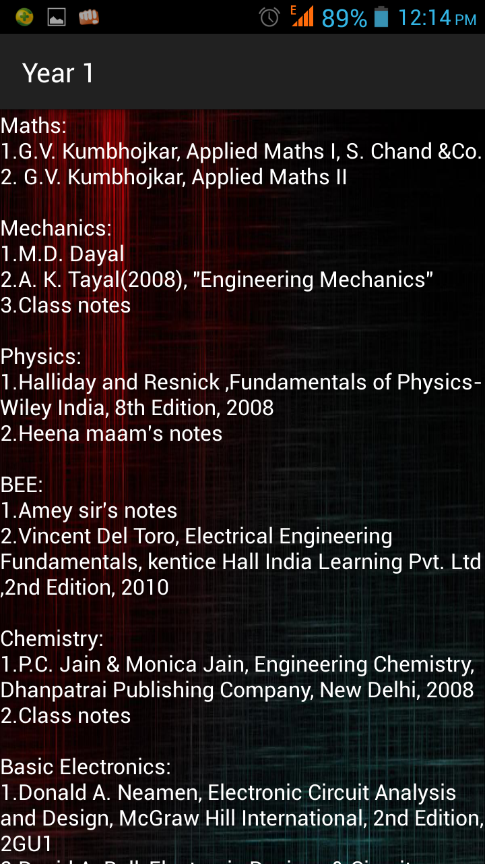

10

* 1. **Limitations of App**
* It gives you just the list of the notes to be studied and does not provide with the actual notes. However we can provide links to download the notes.

11

1. **CONCLUSION AND FUTURE SCOPE**

While creating this app, we learned a lot many things about the android interface, programming in the same using knowledge of java. Apart from the programming, we also learned to design the UI in an interactive manner and make the app as user friendly as possible.

Since this app serves as a resource book, it is college limited. Thus, in future, colleges wanting to implement this app according to their curriculum can buy the proprietary rights and we will provide them with our source code so that they can modify it according to their needs.

12

1. **REFERENCES**

* [www.android.com](http://www.android.com) - January 2015
* [www.vogella.com](http://www.vogella.com) - March 2015
* [www.youtube.com](http://www.youtube.com) - February, March 2015
* [www.stackoverflow.com](http://www.stackoverflow.com) - February, 2015

13